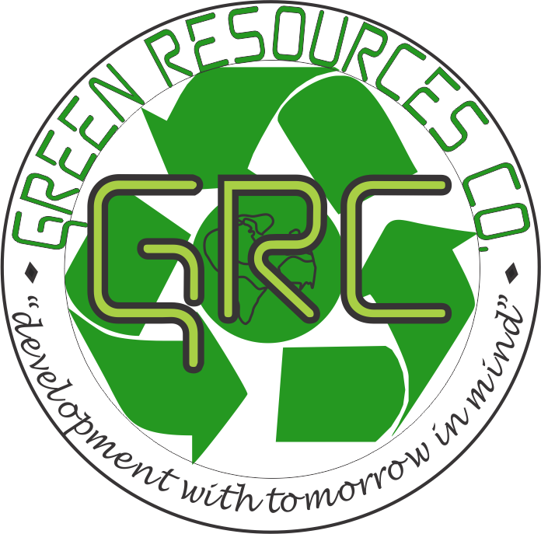
SAFETY, HEALTH, ENVIRONMENT AND QUALITY POLICY
As part of measures and commitments towards the protection of the environment and the safety and health of employees, customers, suppliers and the rest of our stakeholders in the day conduct of business, management and Board of Directors of GRC accepts, as its duty and responsibility, the promotion and upholding of high standards of sustainability, safety and quality in the conduct of our business activities.
GRC is committed to fulfill its objectives by actively participating and promoting effective sustainable programmes of developing today with tomorrow in mind. We shall minimize risks to health and safety of all employees, negative impacts on the environment and ensure delivery of quality goods and services to our valued clients. It is the commitment of the management to ensure that every employee participate in working towards these objectives and continual improvement.
In pursuit to our sustainability, safety and quality policies and objectives, we remain committed to;
- Develop and implement a Go Green Action Plan (GGAP).
- Raising awareness amongst employees, suppliers, customers and interested parties with respect to quality, environment and safety policies and procedures
- Drive a program of continual improvement in all aspects of SHEQ
- Assess work activities by identification of hazards, evaluation of risks and control of major hazards.
- Promote and manage SHEQ as an independent function.
- Drive a culture of quality and best practices.
- To promote responsible actions to exercising care in conserving the natural resources.
- Review this policy on a regular basis, when a significant change to the business occurs or following an incident to ensure that it remains suitable and sufficient to meet the needs of the Company and stakeholder
- Scheduled annual audits to assess current performance levels.
MANAGING DIRECTOR’S COMMITMENT
I am fully responsible for, and commitment to our SHEQ Management Systems based on the ISO 9001:2015 Quality Management Systems; ISO 14001:2015 Environmental Management Systems and OHSAS 45001 Occupational Health and Safety Assessment Series. The management team and staff members are required to share the same responsibility and commitment. Together with, and through them, I will uphold and enforce the management principles as evidenced in this policy and set out in the associated manuals and procedures. 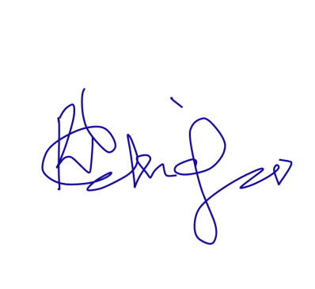 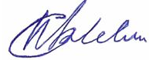
MD SIGNATURE WORKER’S REPRESENTATIVE

